**Manual Test Plan**

1. On opening the app you are redirected to the main profile page which will show you your avatar, user name, Email, no. of repositories, no. of followers and no. of following. The header will show you the page you are on. You can go to the respective pages by clicking on the buttons in the footer.

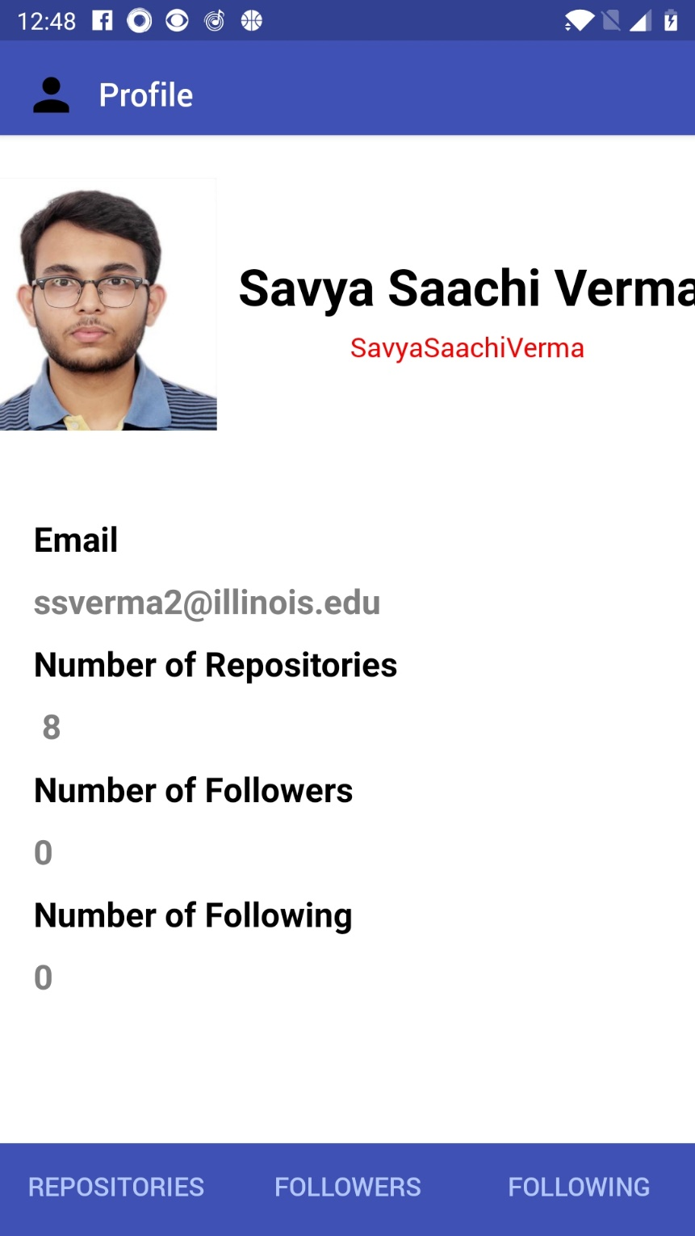

1. On the Repositories page you can see your repositories and the description you have provided along with them.

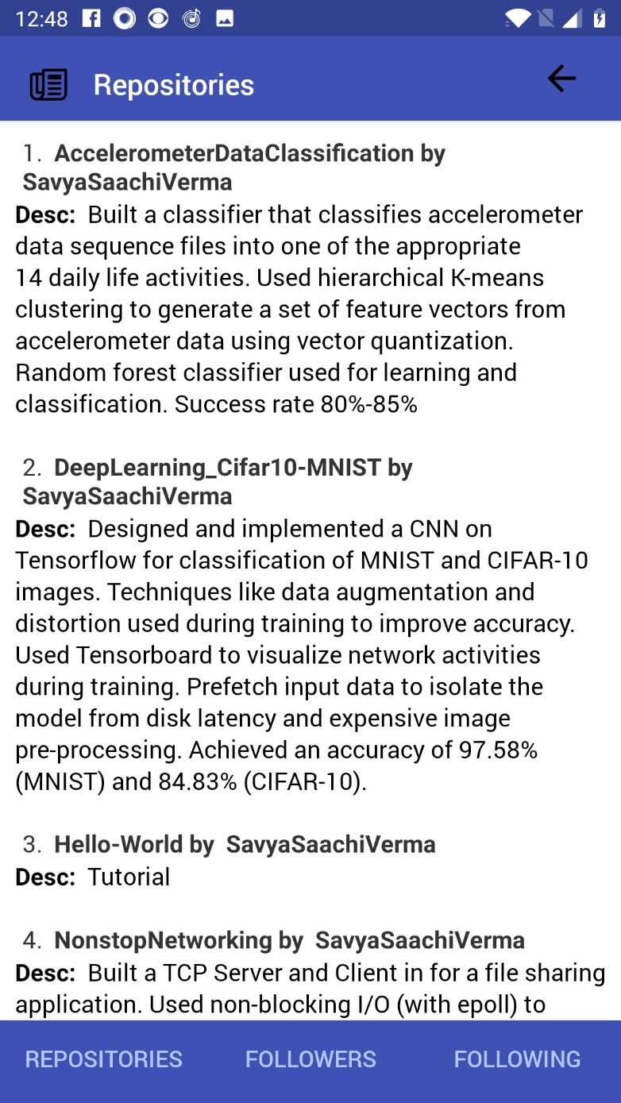You can go back to the profiles page by clicking the back arrow on top right.

1. Followers and following page is currently empty.

